Local tomcat server setup and test.
Landing page
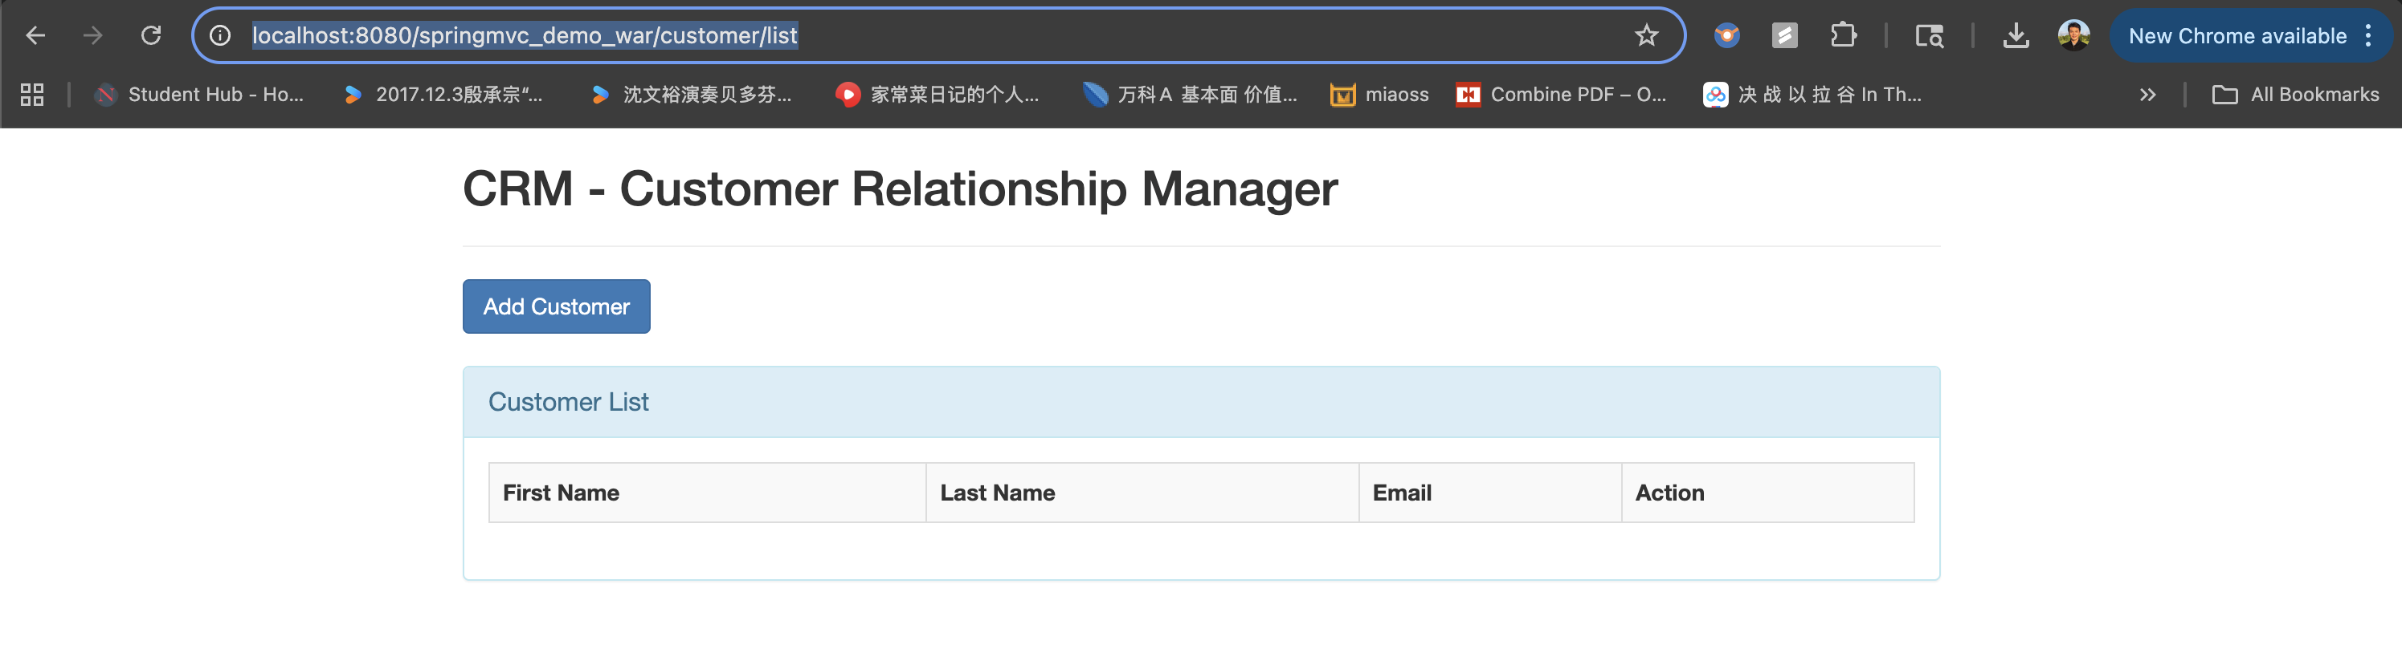
Add a new customer - form
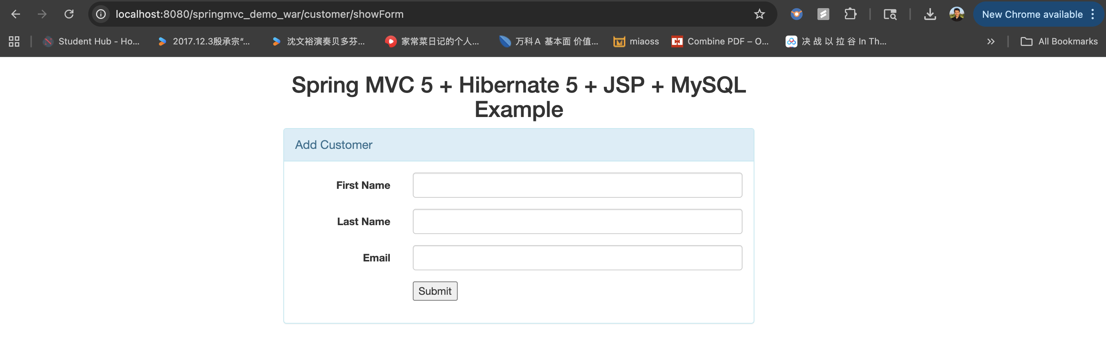
Add a new customer - result
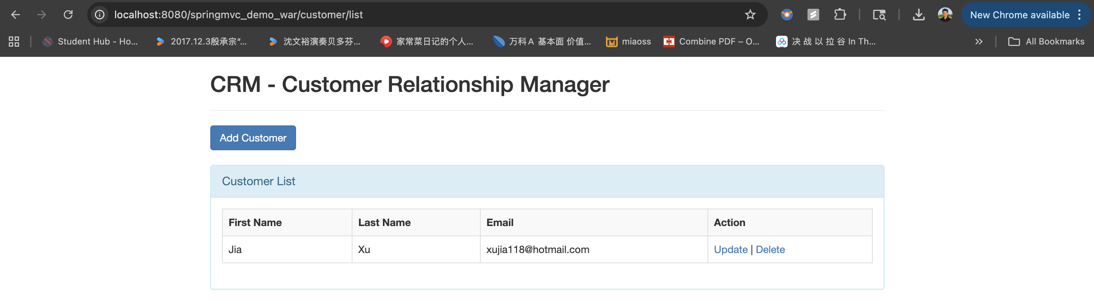

Update user - result
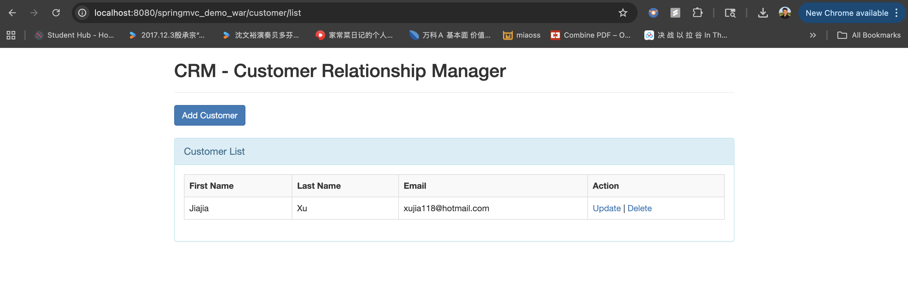

Delete user – pop up
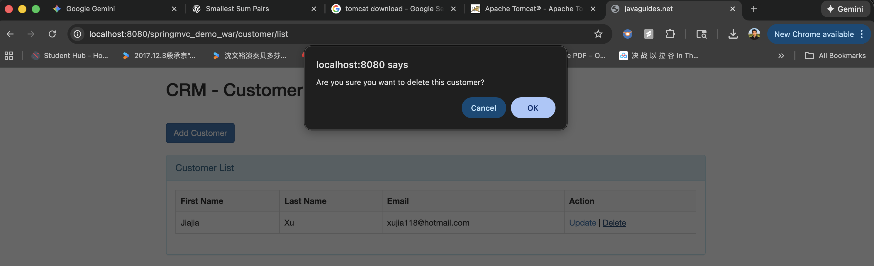

Delete user – result
